# How to run the project

1. Clone Code from: <https://github.com/zshu829/JupiterTest> to local
2. Install Visual Studio 2022 and Chrome version 103
3. After cloning the whole project, Open the project, and find the “UnitTest1.cs” file.

1. Go to Test, then Run All Tests:

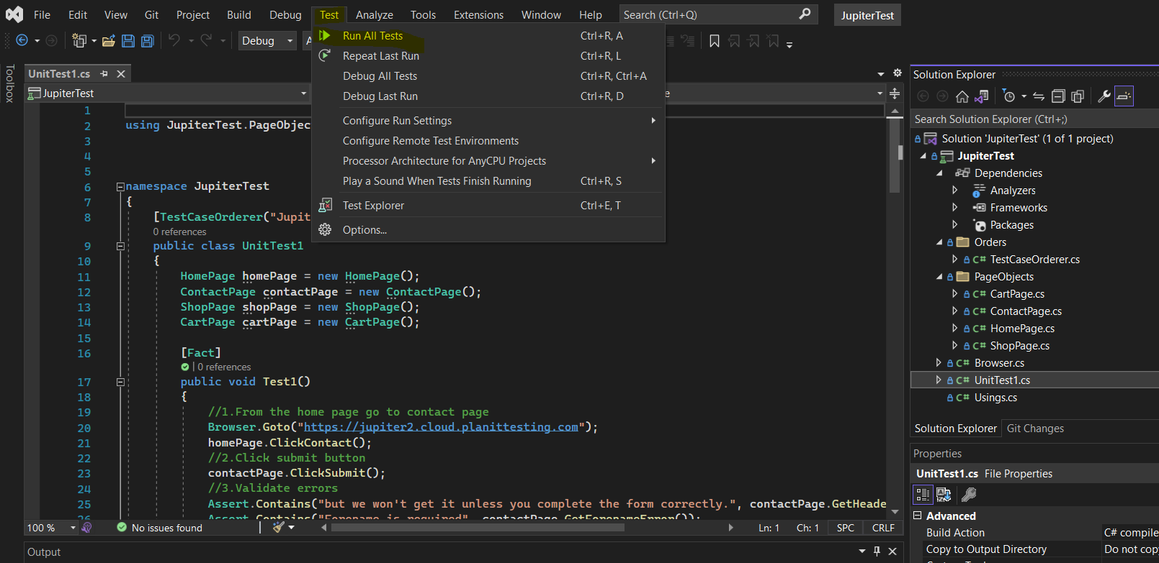

1. Result:

# Project Structure

Following by the requirements, the project structure shows below:

TestCaseOrderer.cs: Control the execution order of test cases.

Browser.cs: Share the IWebDriver object to the whole project.

PageObjects: Objects for mutiple pages

UnitTest1.cs: Test executable file including all testcases.